

Birendra Multiple Campus

Bharatpur-10, Chitwan

PROJECT PROPOSAL ON

**Smart Buy**

Course Code: CSC 412

**Submitted To:**

Binod Sharma

BMC, Bharatpur, Chitwan

**Submitted By:**

Samundra Khanal (21707/075)

Tufan Bhandari (21724/075)

Prabesh Mishra (21686/075)

1. **INTRODUCTION**

Welcome to Smart Buy App, a mobile application designed for the buying and selling of second-hand Mobile phones. This app is a platform where users can buy used mobile phones. It offers a convenient and easy way for people to purchased used devices at a more affordable price than buying a brand new one.

With the increasing cost of new mobile devices, many users are turning to the second hand market to find cost-effective solutions. However finding reliable and trustworthy sources can be a challenging task. This is where Smart buy App comes in, offering a seamless and user-friendly interface that enables buyers to easily search and find the devices they need, while sellers can list their items and reach a wider audience.

The process of using a second-hand mobile buying application typically involves creating an account, browsing through listings of available devices, and making a purchase through the app. Sellers can also list their mobile phones for sale, set a price, and communicate with potential buyers through the app’s messaging system.

Our application include features that make the buying and selling process more secure and reliable, such as user ratings and reviews, verified seller profiles, and secure payment options. It also includes additional features such as device condition assessments and price comparision with new models.

Overall, our Smart Buy application provide a convenient and cost-effective way for consumers to purchase used mobile phones, while also giving sellers an easy way to get rid of their old devices and make extra money.

1. **PROBLEM STATEMENT**

In today's digital age, mobile phones have become an essential part of our lives. With the increasing number of mobile phones available in the market, it can be overwhelming especially for those who can’t afford new ones, to make the right choice. Moreover, with the rise of e-commerce, buying a mobile phone has become even more complex, as users are bombarded with options from different brands, sellers, and price ranges.

To simplify the mobile buying process for users, we aimed to develop a mobile buying application that provides a user-friendly interface and comprehensive information about various mobile phones available in the market. The application should allow users to search, compare, and select mobile phones based on their preferences, such as price range, brand, operating system, camera quality, battery life, and other features.

The application provides users with reviews and ratings from other customers who have purchased the same mobile phone, helping them make informed decisions. The application will be easily accessible and user-friendly, providing a seamless buying experience for users.

Overall, the mobile buying application aims to solve the problem of information overload and confusion faced by users while buying mobile phones online.

By providing a reliable and convenient platform for buying and selling second hand mobile phones, we hope to address the challenges faced by both buyers and sellers, while also contributing to the circular economy by promoting the reuse and recycling of old phones.

1. **OBJECTIVE**

Some of the objectives of this application are listed below:

1. To develop a user-friendly mobile application that simplifies the second-hand mobile buying process for users.
2. To provide comprehensive information about various mobile phones available in the market, including their features, specifications, and prices.
3. To allow users to search, compare, and select mobile phones based on their preferences, such as price range, brand, operating system, camera quality, battery life, and other features.
4. To provide users with reviews and ratings from other customers who have purchased the same mobile phone, helping them make informed decisions.
5. To provide a seamless buying experience for users, with easy-to-use interface and secure payment options.
6. To increase sales and revenue for the mobile phone brands and sellers listed on the application.
7. To continuously improve the application's performance, features, and user experience based on user feedback and market trends.

Overall, our mobile app for buying and selling second-hand smartphones has the potential to provide a wide range of benefits to users, including easier access to affordable parts, reduced waste, and a sense of community among car enthusiasts.

1. **METHODOLOGY**
2. **REQUIREMENT IDENTIFICATION**

Requirement Identification is the process of determining the needs and wants of stakeholders in order to develop a clear and comprehensive understanding of what is required for a project and product. This process involves gathering and analyzing information from a variety of sources, including stakeholders, users, industry, experts and other relevant parties.

The goal of requirement identification is to ensure that the project or product is designed and developed in a way that meet the needs of its users and stakeholders. This involves identifying both functional requirements (what the product or project should do) and non-functional requirements (how the product or project should perform). This process is critical for ensuring that the end product meets the desired outcomes and is delivered on time and within budget.

Requirement identification typically involves several steps, including gathering information about the stakeholders, defining a project scope, conducting a needs analysis, developing requirements documentation, and reviewing and validating the requirements with stakeholders. By following a systematic process for requirement identification, stakeholders can ensure that they have a clear understanding of what is required for a successful project or product, and can avoid costly and time-consuming errors or misunderstandings later in the development process.

1. **Study of Existing System/Literature**

**Review**

The market for buying and selling second-hand mobile phones is a significant one, with many different systems and approaches in place. In general these systems are designed to make it easier for consumers to buy and sell mobile phones that are no longer needed, often as a result of an accident or other issue with a smartphone.

The existing system for buying second-hand mobile phones can vary depending on the location and the platform used for the transaction. Some common methods include:

1. Local Marketplaces: Users can buy and sell second-hand mobile phones through local marketplaces such as Craigslist, Facebook Marketplace, or classified ads in local newspapers. These platforms allow users to connect directly with the seller and negotiate the price and terms of the transaction.
2. Online Marketplaces: Online marketplaces like eBay, Amazon, and Swappa allow users to buy and sell second-hand mobile phones online. These platforms offer a wide selection of mobile phones and typically provide seller ratings and reviews to help buyers make informed decisions.
3. Mobile Carrier Trade-in Programs: Mobile carriers offer trade-in programs that allow users to sell their old mobile phones for credit towards a new device. These programs often provide a lower value for the phone than selling it directly to a buyer, but they are convenient for users who want to upgrade their device.
4. Third-Party Resellers: Third-party resellers like Gazelle and Declutter buy used mobile phones from users and then resell them to other buyers. These platforms offer a streamlined process for selling mobile phones, but they typically offer lower prices than selling the phone directly to a buyer.

Overall, the existing system for buying second-hand mobile phones can be complex and varied, with different platforms offering different benefits and drawbacks. Buyers should carefully research their options and choose a platform that best meets their needs and preferences.

**II. Requirement Analysis**

Requirement analysis is the process of defining, documenting, and validating the needs and expectations for a software system. It is an important step in the software development lifecycle, as it helps to ensure that the resulting system meets the needs of its intended users.

In case of our mobile app which allows buying and selling of second-hand smartphones, the requirement analysis would involve following steps, as mentioned below:

1. Identify Stakeholders:

The first step in requirement analysis is to identify the stakeholders who will be involved in the development and use of the application. In the case of our app, stakeholders might include buyers, sellers and the developing team (our team) who will manage the app.

1. Define goals and objective:

Once the stakeholders have been identified, the next step is to define the goals and objectives of the application. For example, the app might aim to provide a platform for buyers and sellers to connect, make transactions and leave feedback on their experience.

1. Gather requirements:

The next step is to gather the requirements for the application. This involves talking to stakeholders, researching similar apps in the market, and analyzing the needs of the target audience. The requirements might include features such as user registration and login, search and filter options, secure payment processing.

1. Prioritize requirements:

Once the requirements have been gathered, it is important to prioritize them based on their importance to the stakeholders and the feasibility of implementing them with the application. This involves identifying the must-have requirements, the nice-to-have requirements, and the requirements that can be postponed to future updates.

1. Define user stories:

User stories are short description of a feature from the user’s perspective. They help to define the functionality of the application and how it will be used. User stories should be written for each requirement identified in requirements gathering step.

1. Develop use cases:

Use cases are scenarios that describe how a user will interact with the application to achieve a specific goal. They help to define the user experience and ensure that the app meets the needs of its users.

1. Create wireframe and prototypes:

Wireframes and prototypes are visual representations of the app’s interface and functionality. They help stakeholders to visualize the app and provide feedback of its design and utility.

1. Validate Requirements:

Once the wireframes and prototypes have been created, it is important to validate the requirement with stakeholders to ensure that they are accurately represented and meet their needs.

In summary, the requirement analysis of our mobile app that allows buying and selling of second-hand smartphones would involve identifying stakeholders, defining goals and objectives, gathering requirements, prioritizing requirements, defining user stories, developing use cases, creating wireframes and prototypes, and validating requirements. This process is critical to ensuring that the resulting app meets the needs of its intended users and is successful in the market.

1. **FEASIBILITY STUDY**

A feasibility study is an analysis that is conducted to assess the practicality and viability of a proposed project or venture. It involves evaluating the strengths and weaknesses of the project idea, analyzing the market, competition, and financial considerations, and determining whether the project is feasible or not (whether the project is worth starting or Is it possible to start the project?).

Feasibility study in short can be defined as an essential tool for determining whether a proposed project is viable or not. The study assesses the strengths and weaknesses of the project idea, analyzes the market, technical, financial, organizational, legal, and regulatory factors, and identifies potential risks. The results of the feasibility study provide the information necessary to make an informed decision about whether to proceed with the project or not.

Project description which provides a detailed description of the project idea, its scope, objectives, and expected outcomes is one of the major component of feasibility study. Risk Analysis which identifies potential risks associated with the project and proposes strategies to mitigate them is another major component of feasibility study.

1. **Technical feasibility:**

Technical feasibility is an important aspect of the feasibility study for our second-hand mobile buying application. It involves evaluating the technological requirements, constraints, and challenges of developing and implementing the application.

The technical feasibility of the second-hand mobile buying application can be evaluated based on the following factors:

* User interface:

The first thing to consider is how our application will look and feel to users. We will need to design a user interface (UI) that is intuitive, easy to use, and visually appealing. The UI should be optimized with mobile devices and should provide users with all necessary features and functionalities to buy and sell car parts.

* Data Management:

The application will require a database to manage all the data related to the smartphones available for sale, including their make and model, condition, price, and availability.

* Search and Filtering:

We will need to implement a search algorithm that can efficiently and accurately retrieve relevant results.

* Payment gateway:

To enable users to buy and sell smartphones, there should be a secure payment method. In case of our app, the payment is done hand to hand in person to person after the receiving and giving of products which is also a secure payment.

* Security and Policy:

The app will need to comply with relevant security and privacy regulations to protect user data and transactions. We will need to implement various security measures for this.

* Scalability and performance:

Right now we are making this application for limited users but as our app grows in popularity and the number of users and transactions increase, we will need to ensure that it can scale to handle the load.

Based on the availability of the required technology and technical expertise, the technical feasibility of the application can be evaluated. We will have to carefully evaluate these factors and ensure that the application is technically feasible and can be developed and implemented successfully.

1. **Operational feasibility:**

Operational feasibility refers to the ability of a system or project to be implemented and operated successfully within the existing environment or organizational structure. In case of our application, operational feasibility considerations include:

* Market Analysis:

Before launching the app, we need to conduct a thorough analysis of the market for second hand smartphones. We will also need to identify our target audience and their needs and preferences. This will help to design an app that meets their requirements and provides them with a seamless user experience.

* Logistics and supply chain management:

Our app will need to integrate with logistics and supply chain management systems to ensure the timely and efficient delivery of smartphones to buyers. We will need to work with suppliers and logistics providers to ensure that they can meet our requirements and deliver the smartphones to buyers in a timely and cost-effective manner.

* Marketing and Promotion:

To succeed in the competitive market for second-hand smartphones, we will need to develop a comprehensive marketing and promotion strategy. This may involve advertising on social media, search engines, and other channels, as well as building partnerships with relevant organizations and influencers in the automotive industry.

* Financial viability:

Our app will need to generate sufficient revenue to cover its development, maintenance and operating costs, as well as to provide a return on investment to its stakeholders. We will need to develop a sound business model and revenue streams, such as advertising revenues to ensure that the app is financially viable.

* Customer support:

The application should provide robust customer support to buyers and sellers that their queries and concerns are addressed in a timely and professional manner.

Overall, operational feasibility is critical to the success of our mobile app for buying and selling smartphones. We will need to carefully plan and execute each of these operational considerations to ensure that our app meets the needs of our users, complies with regulatory requirements, and generates sufficient revenue to sustain its operations.

1. **Economic Feasibility:**

Economic feasibility is an important aspect of the feasibility study for our second-hand mobile buying application. It involves evaluating the potential revenue and profitability of the application and comparing it with the development and operational costs of the application.

The economic feasibility of our second-hand mobile buying application can be evaluated based on the following factors:

1. Market Size and Growth Potential:

The application should target a large and growing market of second-hand mobile buyers and sellers. The market size and growth potential can be estimated by conducting market research and analyzing industry reports and trends.

1. Revenue Streams:

The application can generate revenue through various streams such as transaction fees, commissions, and advertising revenue. The revenue streams should be carefully planned and optimized to ensure maximum revenue generation.

1. Competition:

The application should be able to compete effectively with other similar applications in the market. The competition can be analyzed by conducting a competitive analysis and identifying the unique value propositions of the application.

1. Cost of Development and Operation:

The cost of developing and operating the application should be estimated accurately to ensure that the application is economically feasible. The cost can include the cost of development, hosting, maintenance, customer support, and marketing.

1. Return on Investment (ROI):

The ROI of the application should be estimated based on the revenue and cost projections. The ROI should be compared with the expected ROI of other investment opportunities to ensure that the application is economically viable.

Based on the analysis of these factors, the economic feasibility of the application can be evaluated. To conclude, we can say that our project is economically feasible as our team members have analyzed these above mentioned factors. The development costs for this application can be said as absolutely free because this application utilizes the internet resources which are totally free. Our team members will only need the device and internet connection for programming the app.

The languages used for programming this application is absolutely free, open-source and also multiplatform.

Language Used for Front-End development: **Kotlin**

For Back-End: **Firebase**

In context of Nepal, in many parts people are still dealing manually for the buying and selling of second-hand smartphones. We have online market like hamrobazaar.com, Daraz.com.np which allows buying and selling of second hand smartphones. It means we understand the competition exists but the positive from this is that people are now involved with online marketplace so they will slowly link with our application as it grows in popularity. Smartphone usages have been increasing rapidly in Nepal which clearly indicates the market demand for such products is rising especially the second-hand products.

These all things indicate that our application is economically feasible.

1. **Schedule feasibility:**

Schedule feasibility is an important aspect of the feasibility study for our second-hand mobile buying application. It involves evaluating the development timeline and ensuring that the application can be developed and delivered within the desired timeframe.

The schedule feasibility of the second-hand mobile buying application can be evaluated based on the following factors:

1. Project Scope:

The project scope should be clearly defined and documented to ensure that the development team has a clear understanding of the application requirements and deliverables.

1. Resource Availability:

The availability of the required resources, including the development team, hardware, software, and other tools, should be evaluated to ensure that the development team has everything they need to complete the project on time.

1. Development Methodology:

The development methodology, such as Agile or Waterfall, should be selected based on the project scope and team expertise. The methodology should be flexible and adaptable to changes in requirements and timelines.

1. Milestones and Deliverables:

The development team should establish clear milestones and deliverables for the project and monitor progress regularly to ensure that the project is on track.

1. Risk Management:

The development team should identify potential risks and challenges that may impact the development timeline and develop contingency plans to mitigate these risks.

Based on the analysis of these factors, the schedule feasibility of the application can be evaluated. If the development team has the required resources and expertise, the project scope is well-defined, and a realistic development timeline has been established, then the application is likely to be schedule feasible. However, if the development team lacks resources or expertise, the project scope is poorly defined, or the development timeline is unrealistic, then the application may not be schedule feasible. Therefore, it is important to carefully evaluate the schedule feasibility of the application before committing to a development timeline.

In conclusion, developing a mobile application for buying/selling second-hand smartphones can be a complex and time-consuming process. However, with careful planning, efficient resource allocation, and effective project management, it is possible to develop this project within a feasible timeline.

**GANTT-CHART**

We have prepared a Gantt-Chart that demonstrates how our developing team members have divided the total development tasks and process into sub tasks.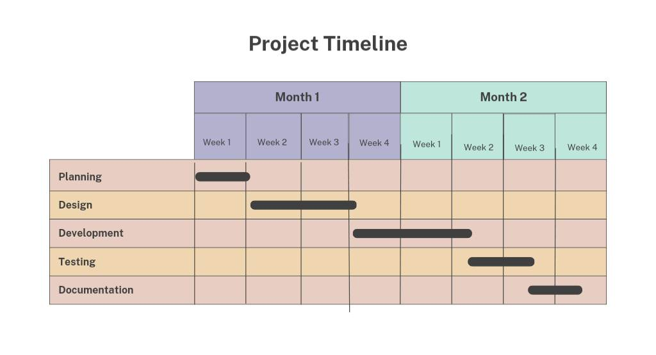

1. **HIGH LEVEL DESIGN OF SYSTEM:**

High level design (HLD) of a software project refers to the process of designing the overall architecture of the system. It involves breaking down the system into different components and modules and defining their interactions and interfaces. The main purpose of HLD is to provide a blueprint for the software project and to guide the development team in building a robust, scalable and maintainable software system.

Designing a mobile application for buying and selling second-hand smartphones involves various components that need to be carefully designed and integrated. A high-level design of a second-hand mobile buying application typically includes the following components:

1. User Interface:

The user interface is the visual and interactive component of the application that users interact with. The interface should be easy to use, visually appealing, and intuitive. The user interface should provide features such as search, filtering, sorting, and a clear view of the product details, images, and seller information.

1. Backend System:

The backend system is the server-side component of the application that processes user requests and handles data storage and retrieval. The backend system should be designed to handle high traffic, and the database should be optimized for fast queries and scalability.

1. Authentication and Authorization:

The application should include a secure authentication and authorization mechanism to ensure that only authorized users can access the application's features. The authentication mechanism should include features such as two-factor authentication and password recovery.

1. Payment Gateway:

The application should integrate with a secure payment gateway to enable buyers to make payments for their purchases. The payment gateway should be secure and reliable to ensure that transactions are processed safely and efficiently.

1. Notifications:

The application should include a notification system to keep users informed about their purchases, sales, and other important events related to the application.

1. Analytics and Reporting:

The application should include analytics and reporting features to track user activity, monitor application performance, and generate insights to improve the user experience and the application's functionality.

Overall, a high-level design of a second-hand mobile buying application should focus on creating a user-friendly and secure platform that facilitates transactions between buyers and sellers of second-hand mobiles. The design should be flexible and scalable to accommodate future growth and feature enhancements.

By following these high level design principles, we can create a robust and user-friendly application that meets the needs of your customers.

Figure below shows the ER-Diagram for High Level Design System of Smart Buy App.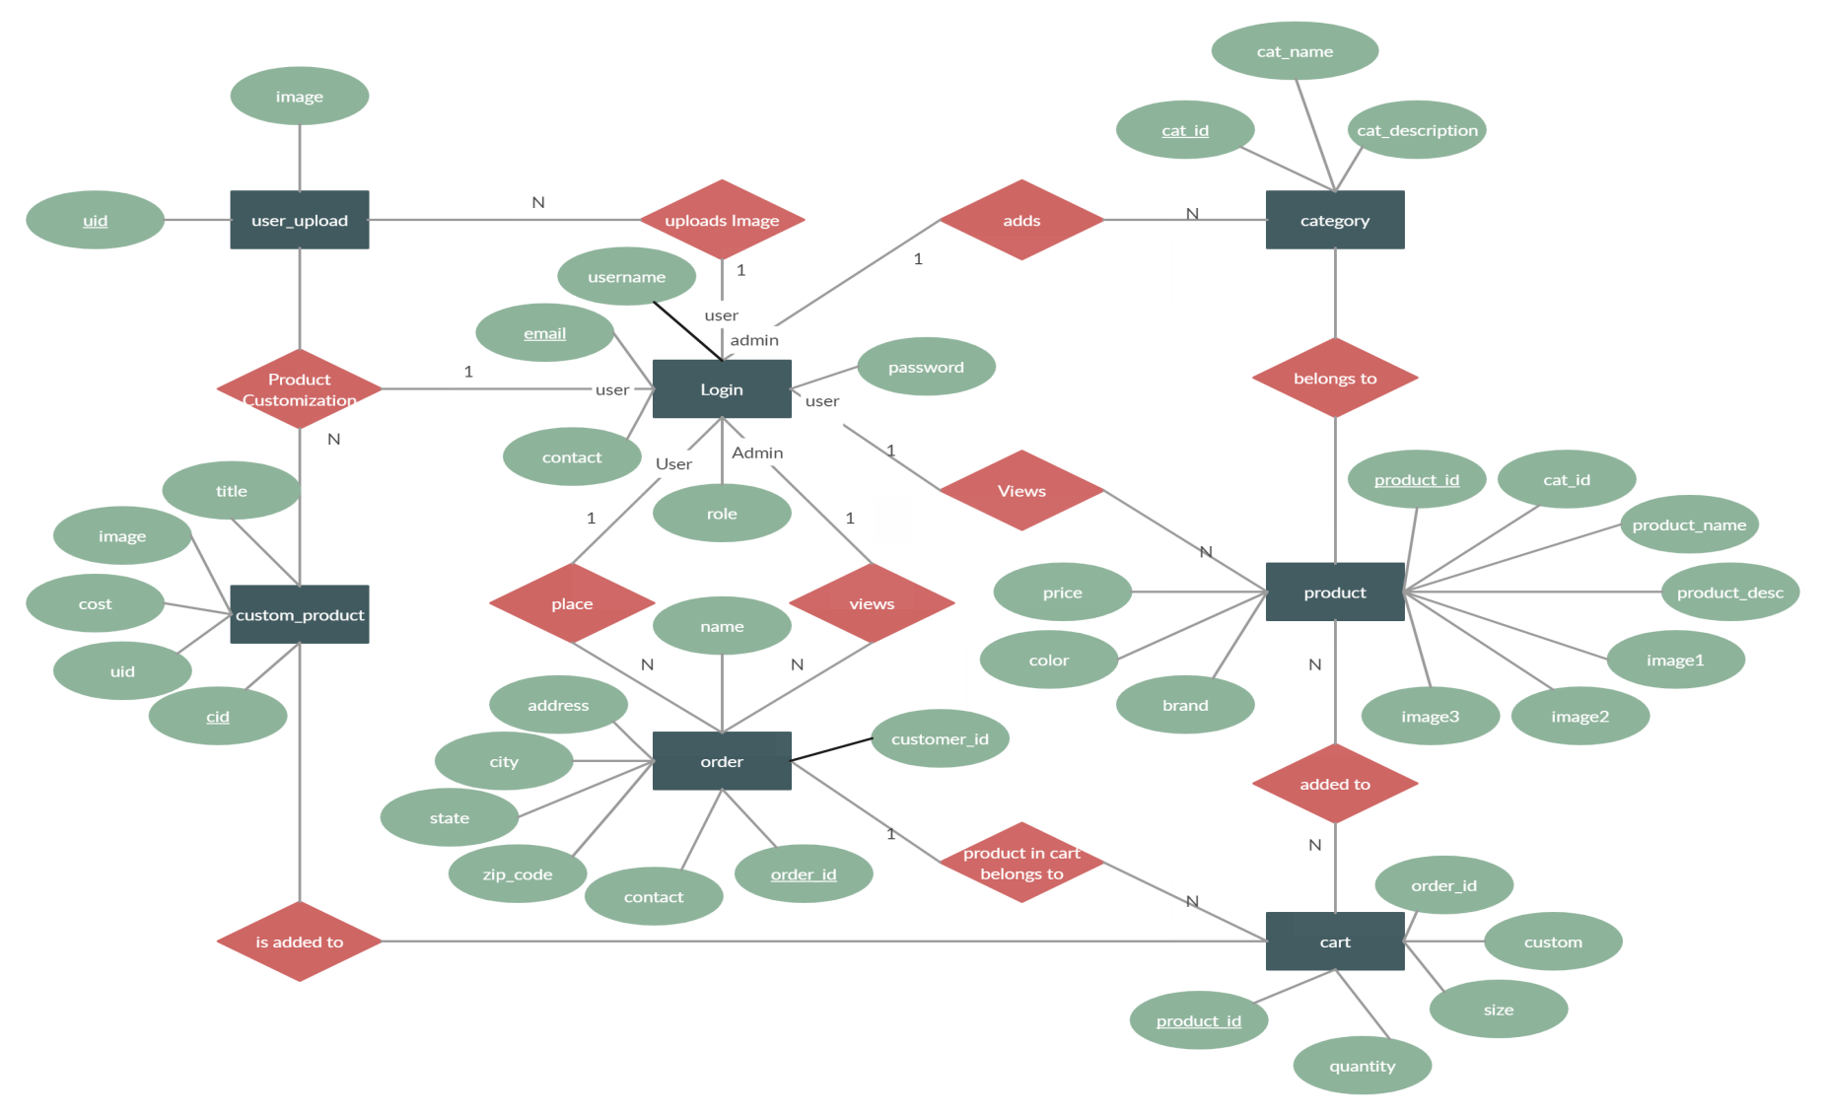

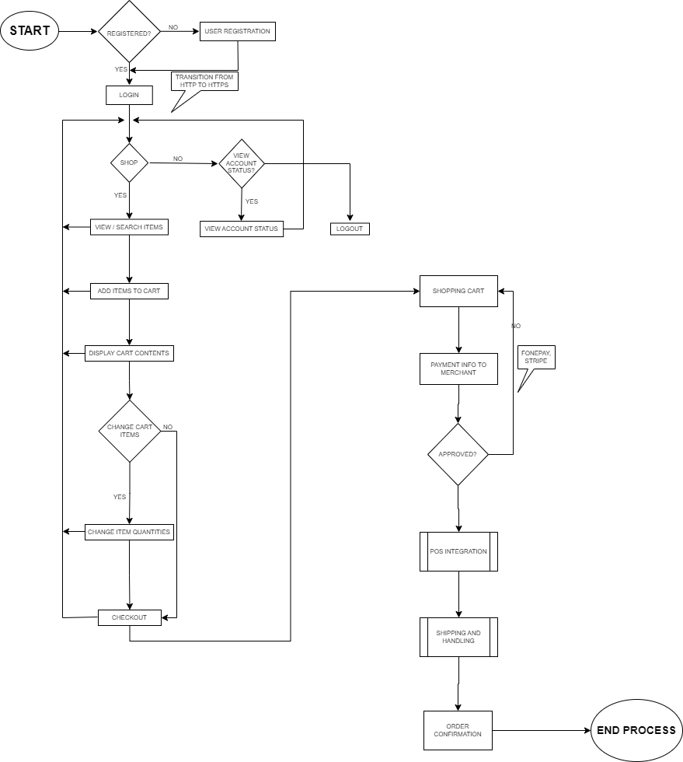

**Fig:** Flowchart of Working Mechanism of Smart Buy App

**WORKING MECHANISM OF PROPOSED SYSTEM**

Here is how the proposed system for Smart Buy app work:

**=>** Users create an account on the app by providing their name, email address and shipping address.

**=>** Users can browse the available smartphone products (second hand or older) by searching for keywords, categories, or using filters such as price or condition.

**=>** When a user finds a smartphone, they are interested in, they can view the listing to see more information about the phone and the seller.

**=>** If the user decides to purchase the smartphone, they can add it to their cart and then the payment process will be carried out.

=> Once the payment process is done, the app will handle the shipping of the smartphone from the seller to the buyer.

**5. EXPECTED OUTCOME:**

The expected outcomes of our second-hand mobile buying application project are numerous, and they depend on the project's objectives and goals. However, some of the expected outcomes of the project are:

1. Increased Access to Affordable Mobile Devices:

The application will provide a platform for users to buy and sell second-hand mobile devices, thus increasing access to affordable mobile devices for people who cannot afford to buy new ones.

1. Improved User Experience:

The application will provide a user-friendly interface that is easy to navigate and intuitive, leading to a better user experience.

1. Increased Transparency:

The application will increase transparency in the buying and selling of second-hand mobile devices. Buyers can view detailed information about the products, including images, seller information, and product condition, leading to increased trust and transparency.

1. Increased Revenue for Sellers:

The application will provide an opportunity for sellers to earn revenue from their unused or unwanted mobile devices, leading to increased income for individuals and businesses.

1. Increased Efficiency:

The application will provide an efficient platform for buying and selling second-hand mobile devices, reducing the time and effort required for transactions.

1. Increased Environmental Sustainability:

The application will promote environmental sustainability by encouraging the reuse and recycling of mobile devices, reducing e-waste and promoting a circular economy.

1. Improved Data Insights:

The application will provide data insights into user behavior, product trends, and performance metrics, leading to better decision-making for the development team and potential business opportunities.

Overall, the expected outcomes of a second-hand mobile buying application project are numerous and can have a positive impact on the environment, individuals, and businesses alike.

In summary, the expected outcomes of our Smart Buy app that allows buying and selling of second-hand smartphones are increased access to second-hand smartphones, enhanced user experience, increased convenience and efficiency, sustainable and environmentally-friendly, and increased revenue for sellers. These outcomes will benefit both buyers and sellers and contribute to the growth of second-hand smartphones market.

**6. REFERENCES:**

1. The main reference for the development of this application is a free course for Kotlin development available in YouTube.

YouTube: freeCodeCamp.org [ <https://youtu.be/EExSSotojVI> ]

1. The second reference is the UDEMY Course which is also available for free.

Android App Development Course with Kotlin | Android A-Z [<https://www.1377x.to/torrent/5118036/Android-App-Development-Course-with-Kotlin-Android-A-Z/#:~:text=Myasiantv-,Android%20App%20Development%20Course%20with%20Kotlin%20%7C%20Android%20A%2DZ,-MAGNET%20DOWNLOAD>]

1. The reference for the Back-end development (firebase) is also free available on YouTube.

YouTube: freeCodeCamp.org [ <https://youtu.be/fgdpvwEWJ9M> ]

1. Kotlin Programming Language: [ [Kotlin Programming Language (kotlinlang.org)](https://kotlinlang.org/) ]
2. Firebase Authentication: [[Firebase Authentication (google.com)](https://firebase.google.com/docs/auth)]
3. Firebase Realtime Database: [ [Firebase Realtime Database (google.com)](https://firebase.google.com/docs/database)]